代码1：
#include<iostream>
#include<string>
using namespace std;
class MyArray{
public:
MyArray(int length);
~MyArray();
void Input();
void Display(string);
protected:
int *alist;
int length;
};
MyArray::MyArray(int leng)
{
if(leng<=0)
{
cout<<"error length";
exit(1);
}
alist = new int [length];
length = leng;
if(alist == NULL)
{
cout<<"assign failure";
exit(1);
}
cout<<"MyArray类对象已创建!"<<endl;
}
MyArray::~MyArray()
{
delete [ ] alist;
cout<<"MyArray类对象已撤销!"<<endl;
}
void MyArray::Display(string str)
{
int i;
int *p=alist;
cout<<str<<length<<"个整数: ";
for(i=0;i<length;i++,p++)
cout<<*p<<"";
cout<<endl;
}
void MyArray::Input()
{
cout<<"请从键盘输入"<<length<<"个整数:";
int i;
int *p=alist;
for(i=0;i<length;i++,p++)
cin>>*p;
}
int main()
{
MyArray a(5);
a.Input();
a.Display("显示已经输入的");
return 0;
}
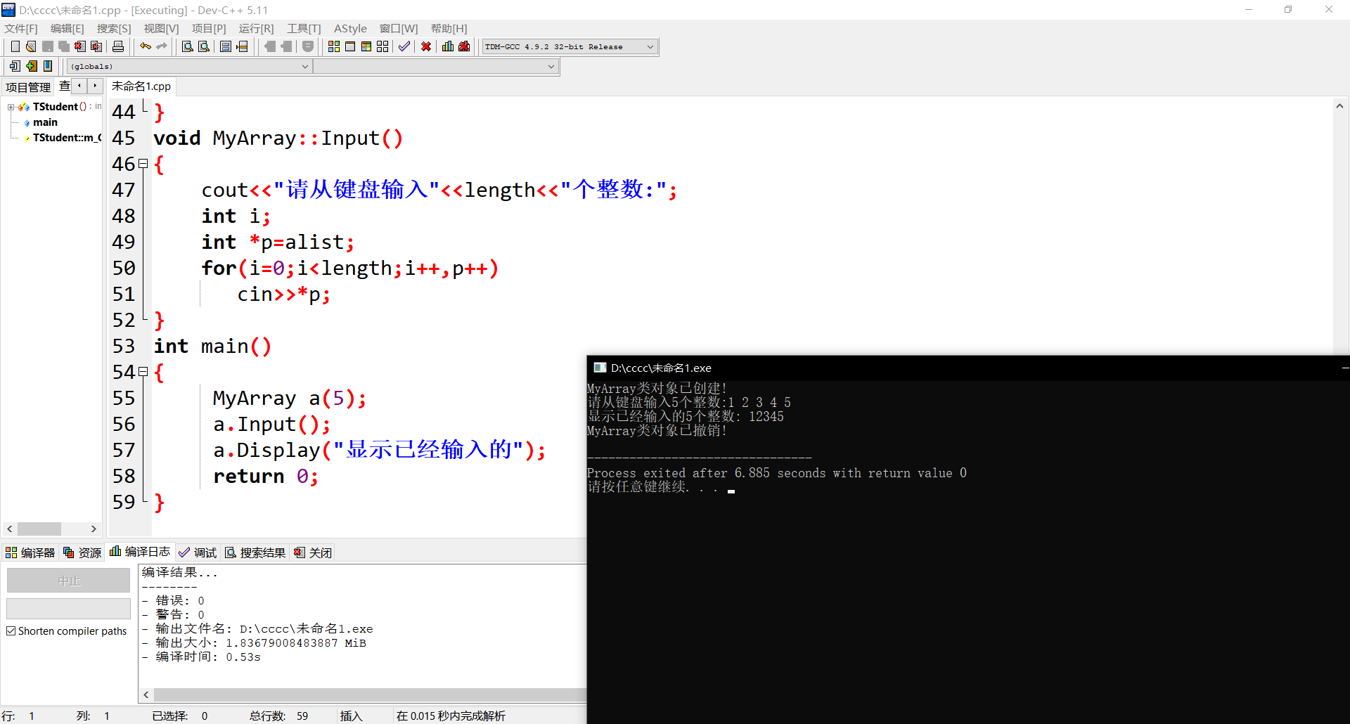
代码2：
#include<iostream>
#include<string>
using namespace std;
class MyArray {
public:
MyArray(int length);
~MyArray();
void Input();
void Display(string);
protected:
int *alist;
int length;
};

MyArray::MyArray(int leng)
{
if (leng <= 0)
{
cout << "error length";
exit(1);
}
length = leng;
alist = new int[length];
if (alist == NULL)
{
cout << "assign failure";
exit(1);
}
cout << "MyArray类对象已创建!" << endl;
}
MyArray::~MyArray()
{
// delete[] alist;
cout << "MyArray类对象已撤销!" << endl;
}

void MyArray::Display(string str)
{
int i;
int *p = alist;
cout << str << length << "个整数: ";
for (i = 0; i < length; i++, p++)
cout << *p << "";
cout << endl;
}

void MyArray::Input()
{
cout << "请从键盘输入" << length << "个整数:";
int i;
int *p = alist;
for (i = 0; i < length; i++, p++)
cin >> *p;
}

class SortArray :public MyArray
{
public:
SortArray(int leng);
~SortArray();
void paixu();
};

SortArray::SortArray(int leng) :MyArray(leng)
{
if (leng <= 0)
{
cout << "error length";
exit(1);
}
length = leng;
alist = new int[length];
if (alist == NULL)
{
cout << "assign failure";
exit(1);
}
cout << "SortArray类对象已创建!" << endl;
}

SortArray::~SortArray()
{
delete[] alist;
cout << "SortArray类对象已撤销!" << endl;
}

void SortArray::paixu()
{
int i, t, j;
int *p = alist;
for (i = 0; i < length-1; i++)
{
for (j = i+1; j < length; j++)
{
if (alist[i] > alist[j])
{
t = p[i];
p[i] = p[j];
p[j] = t;
}
}
}
for(i = 0; i < length; i++)
cout << p[i] << " ";
}
int main()
{
// MyArray a(5);
SortArray b(5);
b.Input();
b.paixu();
cout << endl;
return 0;
}
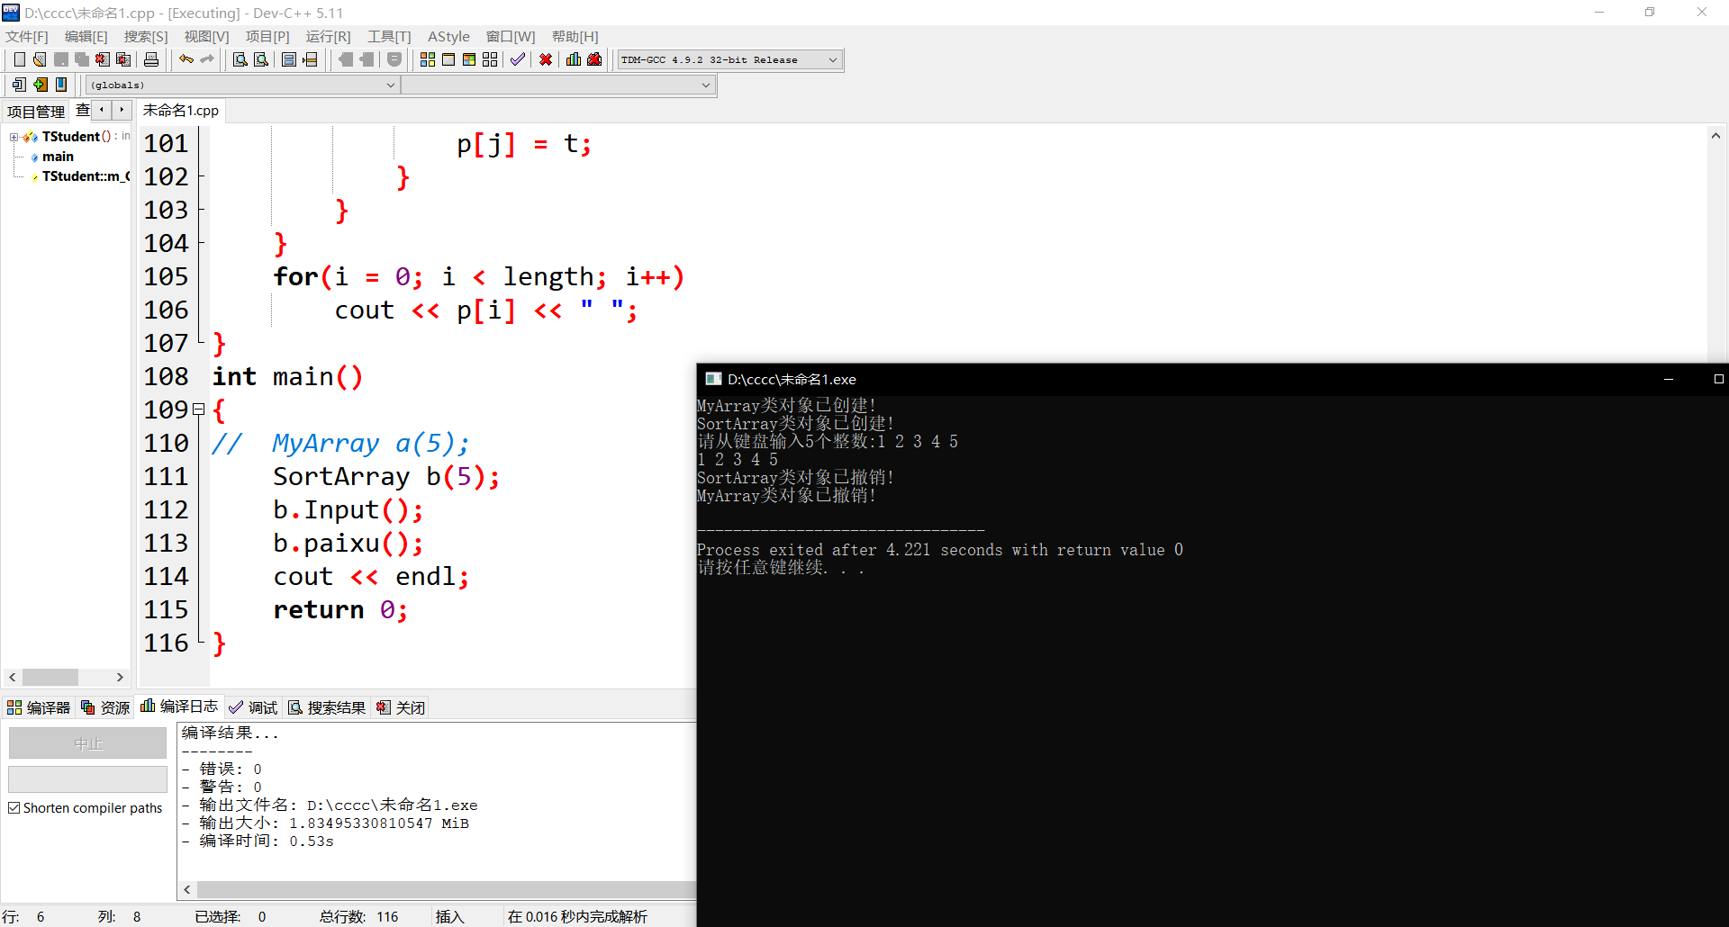
感想：。在学习c++的过程中，我觉得嵌套循环和指针最不能让我理解。以后学习C++还需要多多钻研 。学习c++编程，老师的课程视频不能落下，甚至要反反复复多看几遍，也离不开上机实践。通过编程和上机调试程序，会发现许许多多的问题，无论大的还是小的，通过解决这些问题，不仅可以检验自己是否真正的掌握了所学的内容，还可以加深对所学知识的理解，积累编程和调试经验，提高自己的实际编程能力。

